Housing Price Range Classification for Informed Property Purchases
Yi-Yung Chen
Abstract
This paper focuses on the key factors in predicting housing prices to help home buyers make better decisions to avoid overpaying. The author first preprocesses the data and then use the classification technique to generate models such as decision tree, random forest, and Naïve Bayes to predict the ranges of house prices by using key factors such as location, house condition, amenities, and property features.
Introduction
“According to a report by Harvard researchers in 2017, 1 in 3 renters and buyers overpay for their housing. That figure represents about 39 million Americans. First-time home buyers are even more likely to overpay on a house.” (McDowell, 2019, para 2)
Lots of first home buyers overpay for their properties due to their lack of knowledge of the real estate market. The author uses a data mining technique called binning to put home prices into three intervals, low, medium, and high, then uses the classification technique to predict housing prices. By using the classification technique, we can see whether the housing prices can be predicted by factors such as location, included area, bedrooms, bathrooms, stories, amenities, and furnishing status. The objective of this paper was to focus on whether these factors play a role in predicting housing prices, so that it can serve as a valuable source for home buyers. The goal was to create a resource that helps buyers gain advantages in the real estate market by providing them valuable knowledge, so that they can make better choices when purchasing a property.
Data Collection and Preprocessing
1.Data sources
The author uses a dataset that includes housing details, covering factors such as location, included area, bedrooms, bathrooms, stories, amenities like air conditioning and parking, information on furnishing status, and housing price data. The sources tapped for this dataset range from multiple resources and web scrapping. This data contains 13 attributes and 545 records.
- Price: The price of the house.
- Area: The total area of the house in square feet.
- Bedrooms: The number of bedrooms in the house.
- Bathrooms: The number of bathrooms in the house.
- Stories: The number of stories in the house.
- Mainroad: Whether the house is connected to the main road (Yes/No).
- Guestroom: Whether the house has a guest room (Yes/No).
- Basement: Whether the house has a basement (Yes/No).
- Hot water heating: Whether the house has a hot water heating system (Yes/No).
- Airconditioning: Whether the house has an air conditioning system (Yes/No).
- Parking: The number of parking spaces available within the house.
- Prefarea: Whether the house is located in a preferred area (Yes/No).
- Furnishing status: The furnishing status of the house (Fully Furnished, Semi-Furnished, Unfurnished).
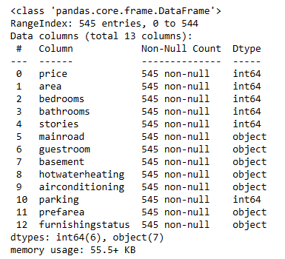

2.Data Preprocessing
In this paper, Python is the only tool used for date preprocessing. Data preprocessing includes tasks such as data cleaning, normalization, and managing missing value. This dataset contains no missing values. Therefore, there is no need to handle missing data. However, binning by equal frequency was introduced to housing prices. Divides the price range into three intervals, high, medium, and low, each containing approximately the same number of samples. Binning method can be used for several reasons, such as simplifying the model, handling noisy data, reducing sensitivity of outliers etc.
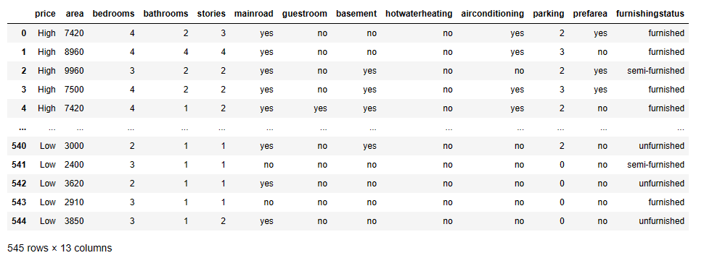
Furthermore, some of the attributes contain yes or no, such as main road, guestroom, basement, hot water heating, air conditioning, and prefarea. Those values must be replaced by 0 and 1, the data type must be numerical since scikit-learn does not support categorical data. Likewise, the values in furnishing status must be transferred to dummy data.
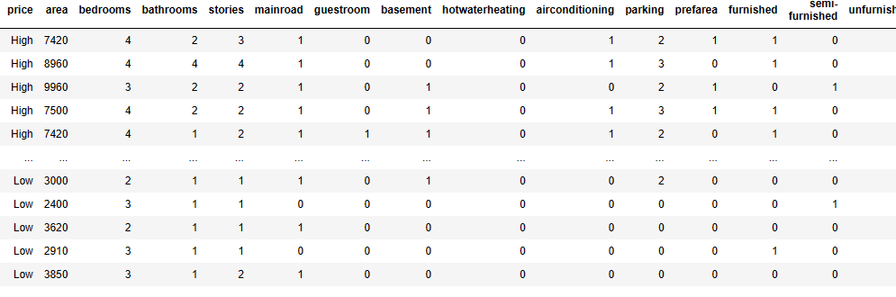
Methodology
1. Feature Selection
Selecting the right attributes plays an important role in accurately classifying price ranges. The author uses heat map to select relevant attributes to improve model accuracy and reduce overfitting situation. The heat map shows the correlation between price and each attribute. If the number between price and a feature is closer to one, the block between price and the attribute will show a lighter color, meaning the feature is highly correlated with the price and vice versa.
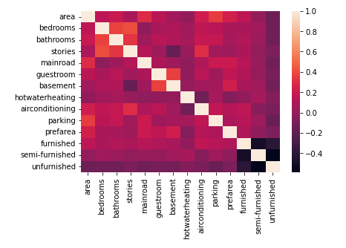

2. Machine Learning Models
The author uses a mix of supervised machine learning models, such as Decision Tree, Random Forrest, and Naïve Bayes. These models are chosen for their ability to navigate complex relationships within the dataset. The primary purpose of these models is to learn patterns from data and make predictions or decisions. Python is the only tool used for this part of paper. Here are the steps:
- Create training and test data split. Use 80% on training set and 20% on test set to avoid overfitting.
- Build the three classifiers, Decision Tree, Random Forest, and Naïve Bayes from the training set.
- Create predictions from the test set.
3. Model Evaluation
To measure model performance, this author evaluates model effectiveness using metrics such as accuracy, precision, recall, and F1 score. As we can see from the report, Naïve Bayes Classifier provides the best accuracy out of these three classifiers, the accuracy of prediction appears to be 72.5%. Therefore, Naïve Bayes Classifier is a better model in terms of accuracy in this case.
Here are the results:
- Generate classification reports.
- Evaluate the accuracy of predictions.
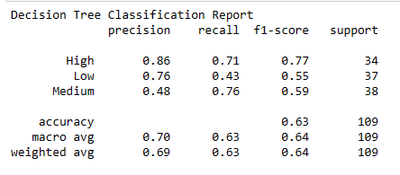
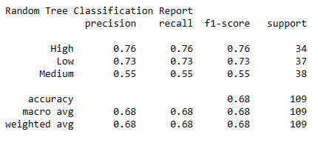
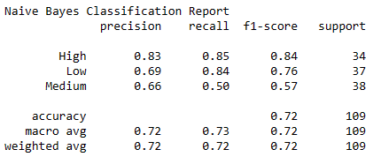
Results
This part of the section presents decision tree rules. They will be presented by a visualization and export_text. To avoid overfitting situation, 3 was applied as the max depth. From the Decision Tree Rules, we can see area was the first attribute selected to build the tree due to its highest Gini, 0.666. Price tends to be in a lower tier when the house area is smaller, unfurnished and less stories. When the house area is bigger and more stories, the housing price tends to be in the higher tier.
Here are the decision tree rules shown by visualization and export_text:
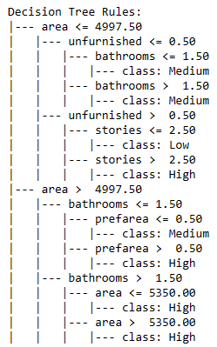
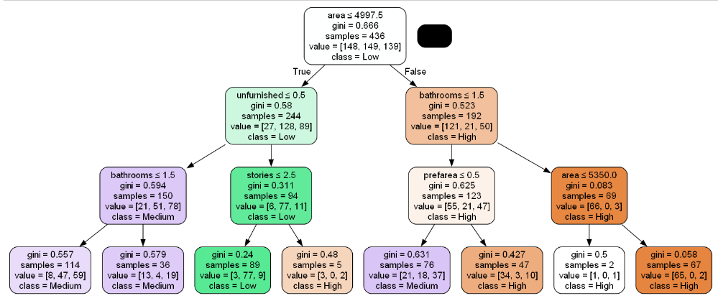

Conclusion
In summation, the objective of this paper was to see whether hosing prices can be predicted by factors such as location, area size, number of bedrooms and bathrooms, stories, as well as amenities and furnishing status. Using the classification technique, the author was able to form several models that prove housing prices can be predicted by these factors, especially with Area being the most influential factor due to its highest Gini. This report will serve as a valuable tool that helps home buyers to make more informed decisions, so that they don’t overpay for the property.

Reference

“The biggest signs you're overpaying on a house — and 5 ways to avoid it” (McDowell)
https://www.businessinsider.com/the-biggest-signs-youre-overpaying-on-a-house-2019-7

“Housing Price Prediction” (Kumardatalab)
https://www.kaggle.com/datasets/harishkumardatalab/housing-price-prediction

